Name: Amogh Nagarkar

Super Set ID: 6403503

**Objectives**

* Explain how to clean up and push back to remote Git

In this hands-on lab, you will learn how to:

* Execute steps involving clean up and push back to remote Git.

**Solution:**

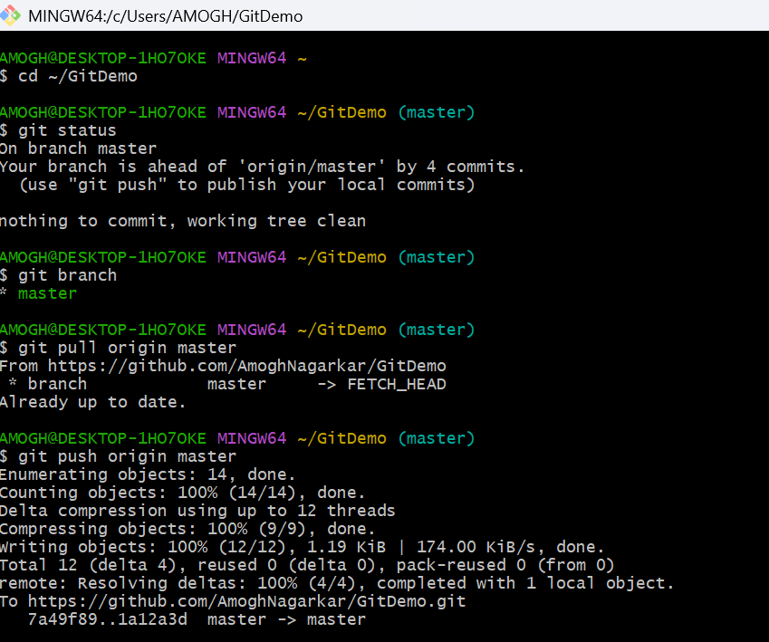

* Verified that the master branch was in a clean state.
* Listed all available branches in the repository.
* Pulled the latest changes from the remote repository into master.
* Pushed pending changes from previous hands-on work to the remote repository.
* Confirmed that the changes were successfully reflected in the remote repository.